|  |  |
| --- | --- |
| NAME | S.SATHISH |
| NM ID | D3AB4E60998F2BBA802428A0FF7D9B00 |
| PROJECT | CREATING A LANDING PAGE IN HUBSPOT |

**CREATING A LANDING PAGE IN HUBSPOT**

**INTRODUCTION:**

Creating a landing page in HubSpot is a critical step in your inbound marketing strategy. Landing pages serve as a gateway for converting website visitors into leads and ultimately, customers. They are designed to capture essential information from your visitors in exchange for valuable content or offers. In this guide, we'll walk you through the process of creating a highly effective landing page in HubSpot, from setting your goals and understanding your target audience to designing an engaging page and optimizing it for maximum conversions.

By the end of this tutorial, you'll have a clear understanding of the best practices, tools, and strategies that will help you design a HubSpot landing page that not only looks great but also maximizes lead generation and engagement. So, let's dive in and start creating landing pages that will help you achieve your marketing goals and grow your business.

**WELCOME NOTE:**

Welcome to our healthcare, wellness, and fitness community! We're thrilled to have you here as a part of our journey towards a healthier and happier life. At our core, we are dedicated to promoting overall well-being and vitality for all.

In this space, you'll find a wealth of information, resources, and support to help you achieve your health and fitness goals. Whether you're looking to improve your physical health, mental well-being, or simply seeking inspiration and guidance on your wellness journey, you're in the right place.

Our community is more than just a collection of articles and advice; it's a place where you can connect with like-minded individuals who share your passion for health and fitness. Here, you'll have the opportunity to learn, share, and grow together.

We understand that everyone's path to wellness is unique, and we're committed to providing you with the tools and knowledge you need to make informed choices about your health. So, take a moment to explore, ask questions, and get involved. We're excited to be a part of your health and wellness journey, and we look forward to supporting you every step of the way.

Here's to a healthier, happier you! Welcome to our healthcare, wellness, and fitness community.

**STEP 1:**

Creating an account in HubSpot

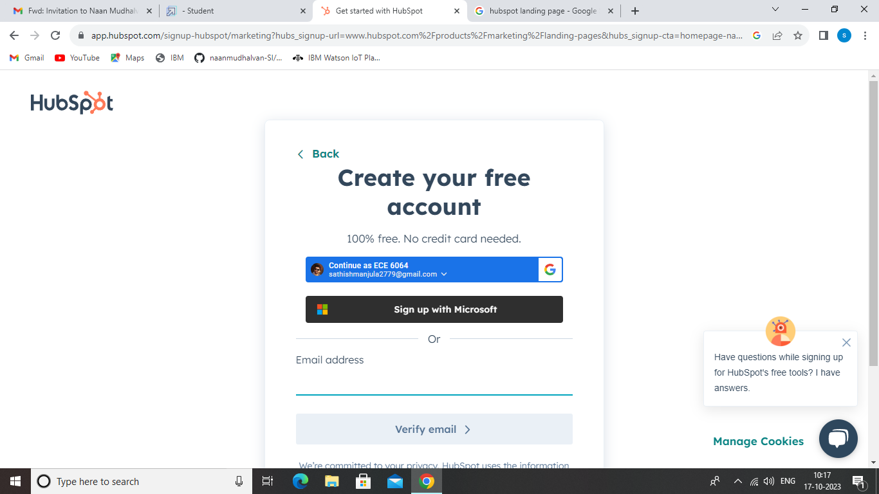

**STEP 2:**

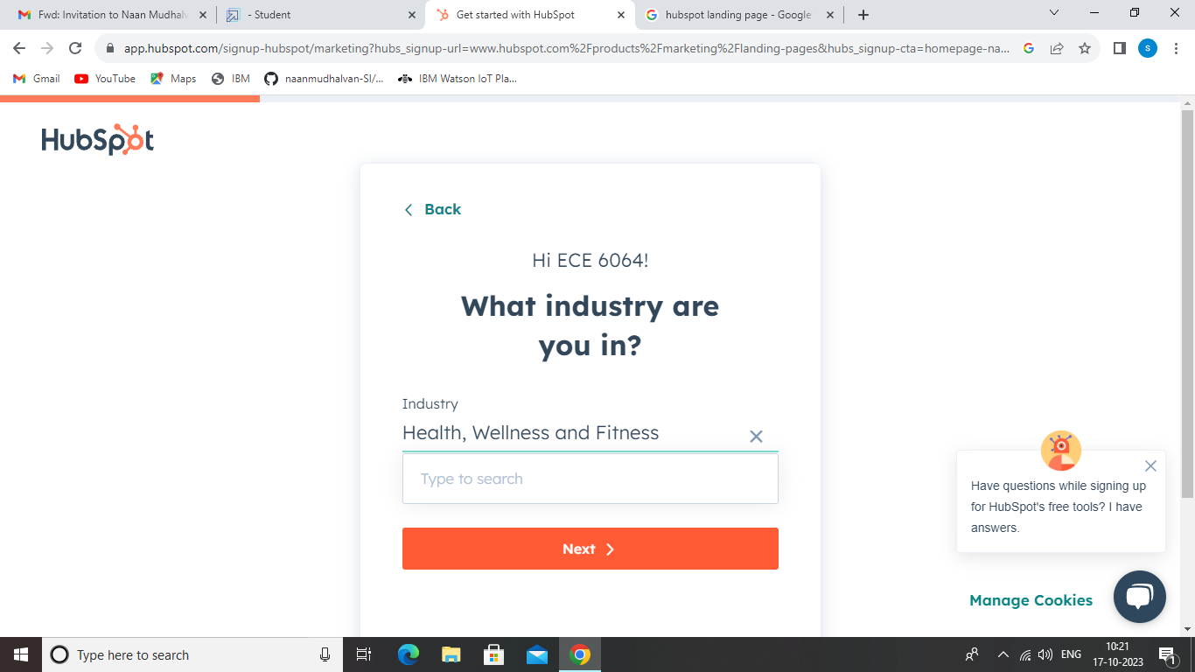

**STEP 3:**

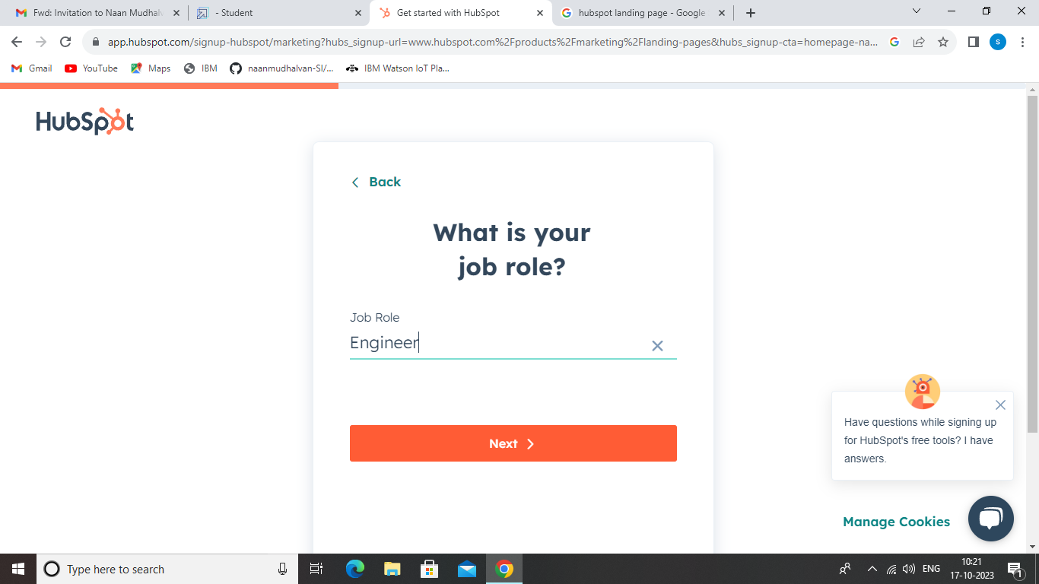

**STEP 4:**

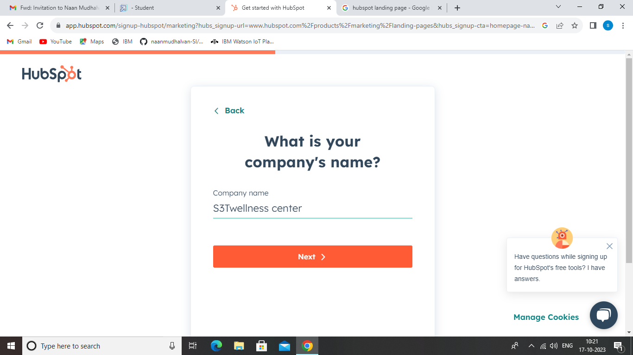

**STEP 5:**

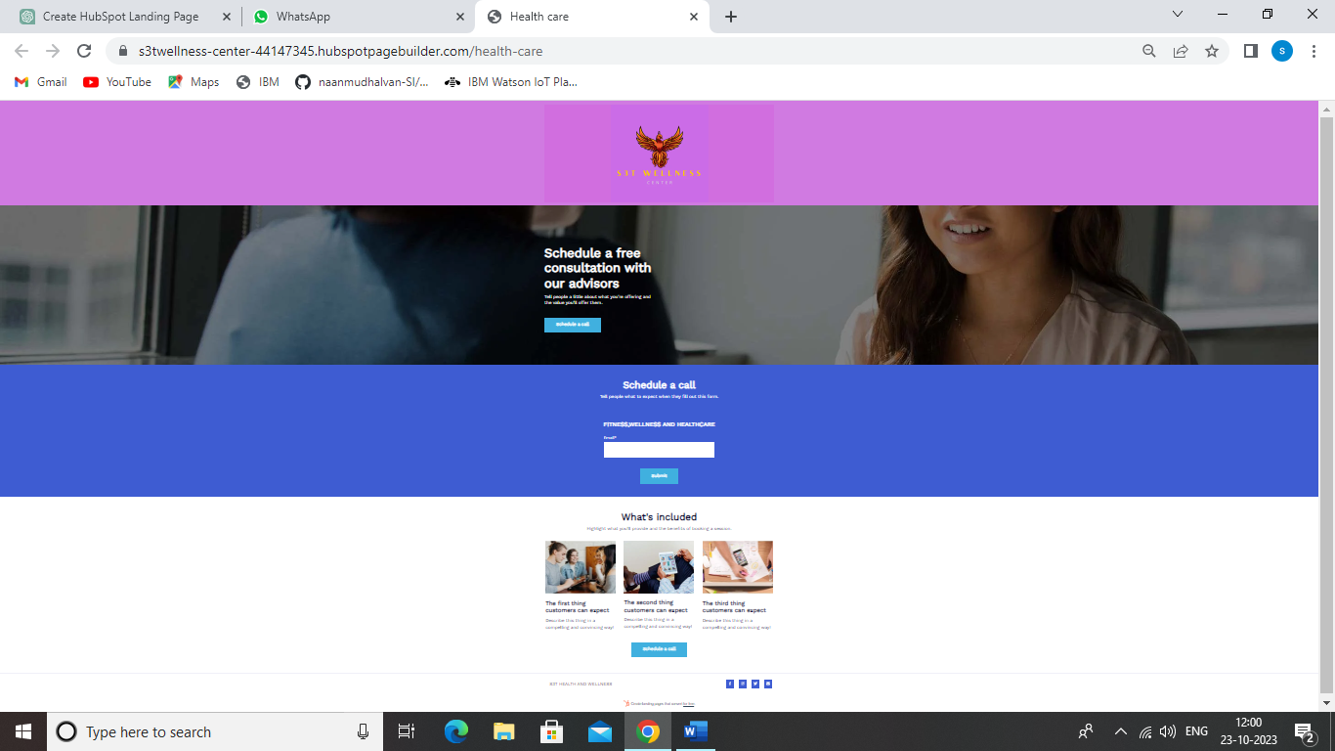

**EMPATHY MAP:**

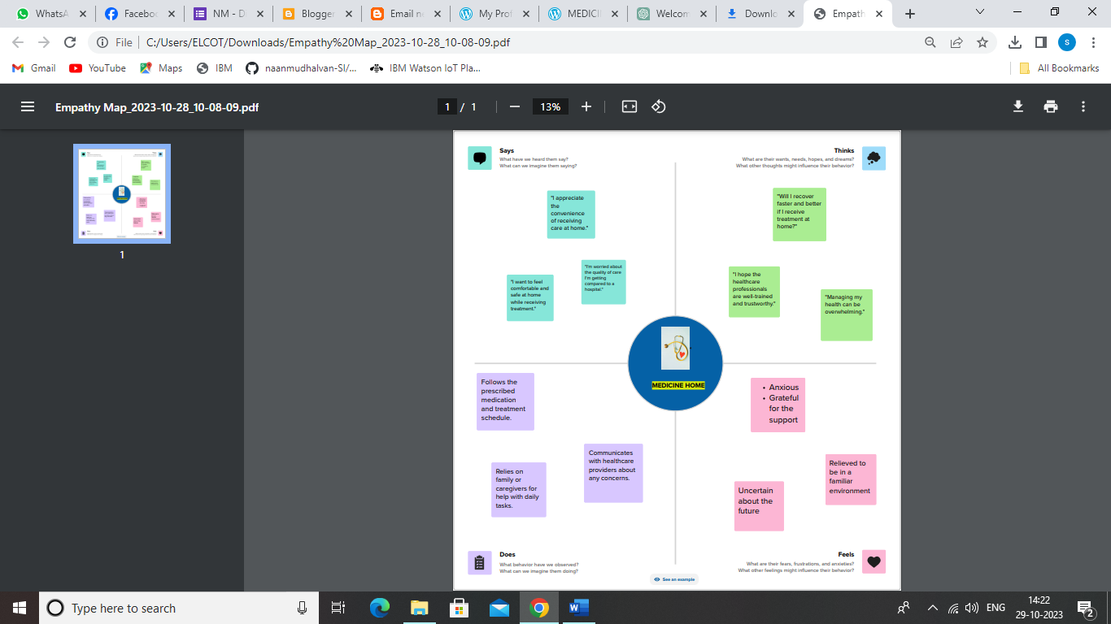

**EMPATHY MAP LINK:**

[**https://app.mural.co/t/landingpage4369/m/landingpage4369/1698486759674/452bf4aaf66c0b0336b0bd0d0342d1b6f5b81aa7?sender=u83846649c59736fc18bc0774**](https://app.mural.co/t/landingpage4369/m/landingpage4369/1698486759674/452bf4aaf66c0b0336b0bd0d0342d1b6f5b81aa7?sender=u83846649c59736fc18bc0774)

**BRAINSTORMING AND IDEA PRIORITIZATION:**

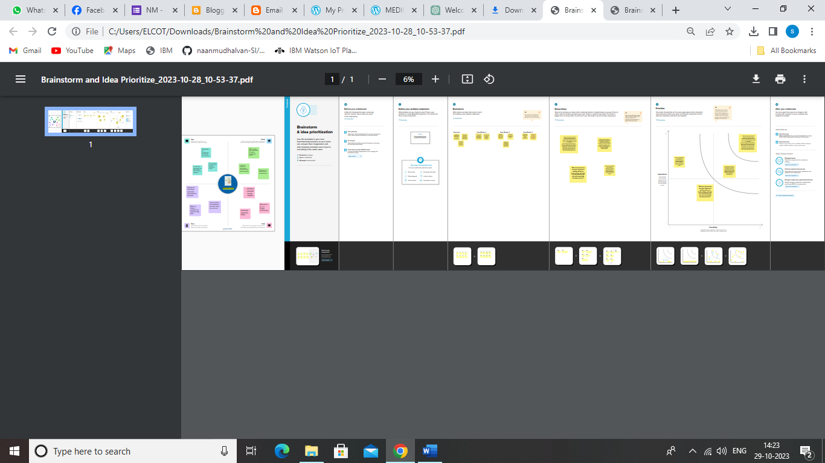

**BRAINSTORMING AND IDEA PRIORITIZATION LINK:**

[**https://app.mural.co/t/landingpage4369/m/landingpage4369/1698486759674/452bf4aaf66c0b0336b0bd0d0342d1b6f5b81aa7?sender=u83846649c59736fc18bc0774**](https://app.mural.co/t/landingpage4369/m/landingpage4369/1698486759674/452bf4aaf66c0b0336b0bd0d0342d1b6f5b81aa7?sender=u83846649c59736fc18bc0774)

**DEMONSTRATION LINK:**

[**https://youtu.be/FGaF1kHn0JU?feature=shared**](https://youtu.be/FGaF1kHn0JU?feature=shared)

**CONCLUSION:**

Creating a landing page in HubSpot is a critical step in your inbound marketing strategy. Landing pages serve as a gateway for converting website visitors into leads and ultimately, customers. They are designed to capture essential information from your visitors in exchange for valuable content or offers. In this guide, we'll walk you through the process of creating a highly effective landing page in HubSpot, from setting your goals and understanding your target audience to designing an engaging page and optimizing it for maximum conversions.

By the end of this tutorial, you'll have a clear understanding of the best practices, tools, and strategies that will help you design a HubSpot landing page that not only looks great but also maximizes lead generation and engagement. So, let's dive in and start creating landing pages that will help you achieve your marketing goals and grow your business.